# RGB strip light

## 一、Learning objectives

Use the STM32F103RCT6 to control RGB strip lights

Note: If you only connect the ST-Link programming program without using the Type-C interface to supply power, the light bar is likely not to light up, it is recommended to connect both; Or directly use the Type-C interface to download the program and power supply

## 二、Prepare before class

Hardware: STM32F103RCT6 core board, RGB strip light, DuPont line

**Hardware wiring (5 lamp beads)**

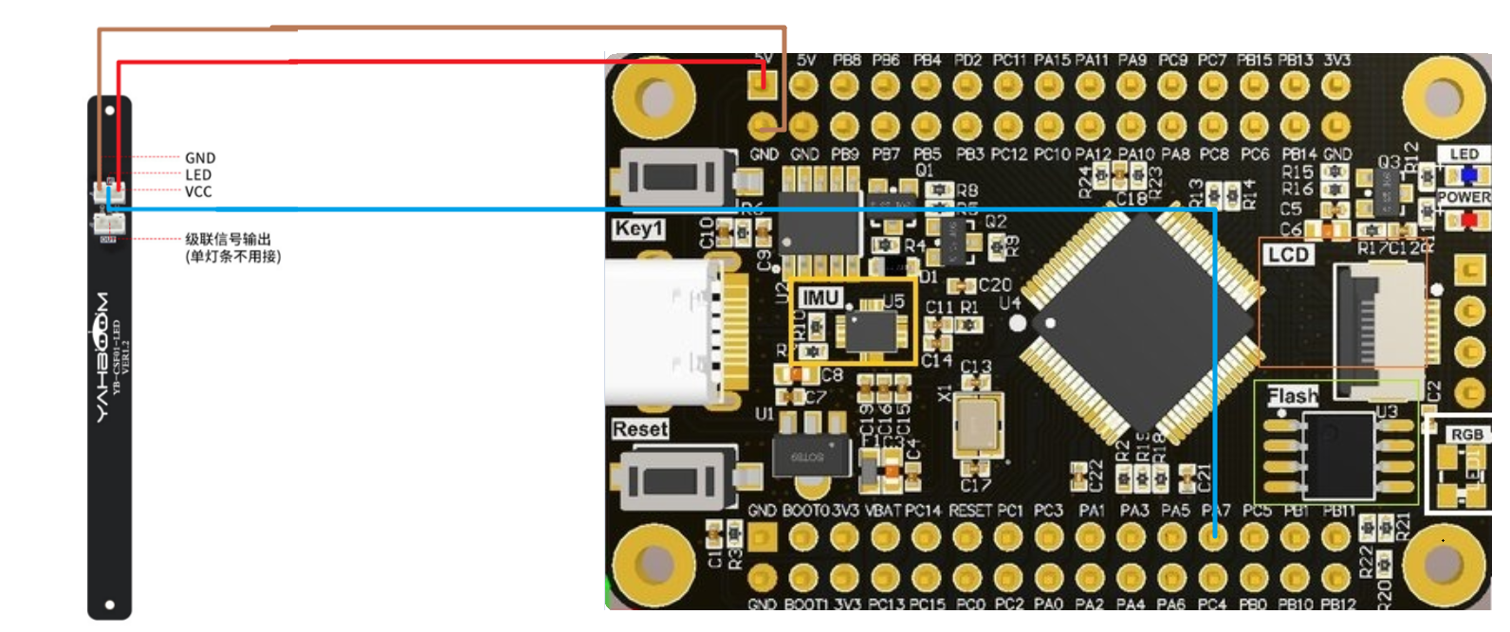

**Hardware wiring (14 lamp beads)**

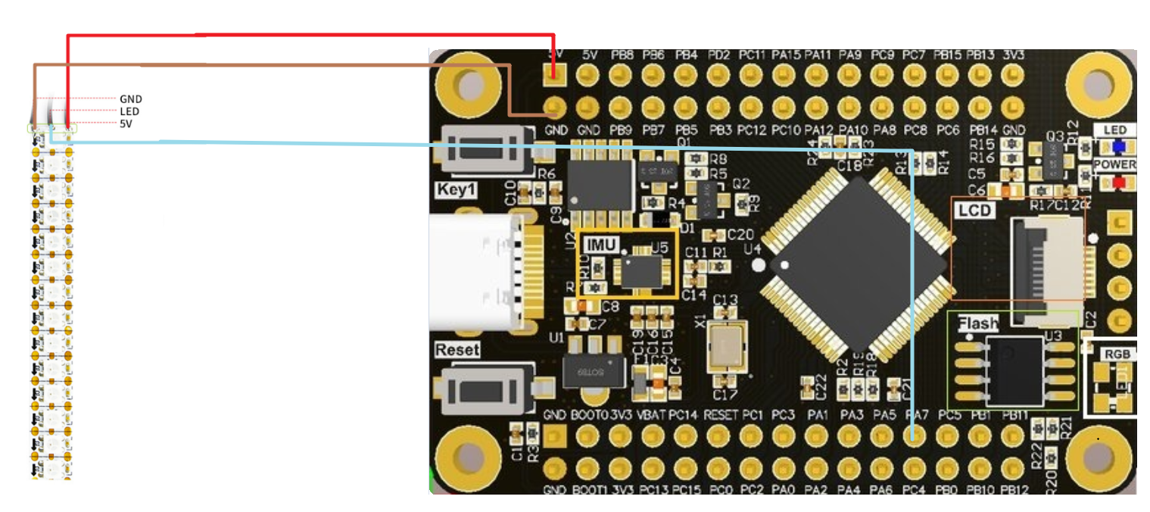

## 三、RGB lights

Note: The only difference between the RGB strip light bar 5 bead number and 14 lamp bead number program is the number of lamp beads defined in the program.

### 1. Major code interpretation

* 1. GPIO PA5 PA7 initialization

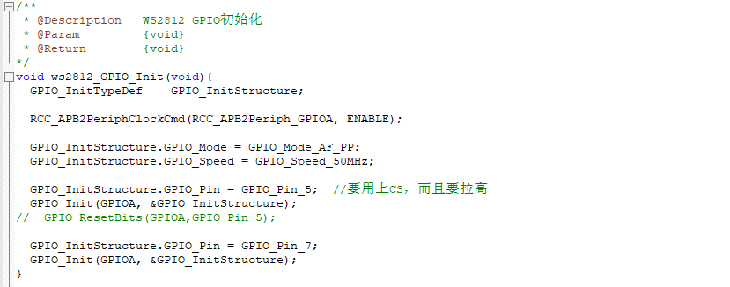

* 1. SPI initialization

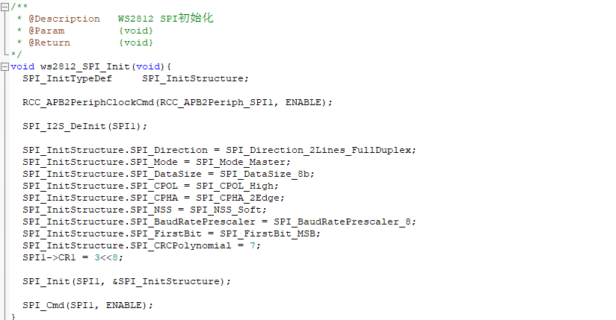

* 1. DMA initialization

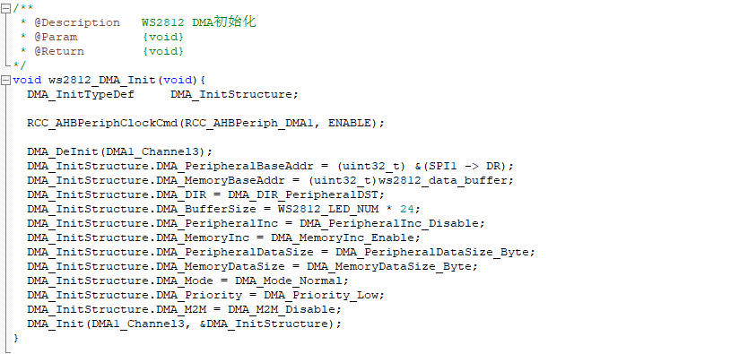

* 1. ws2812 initialization

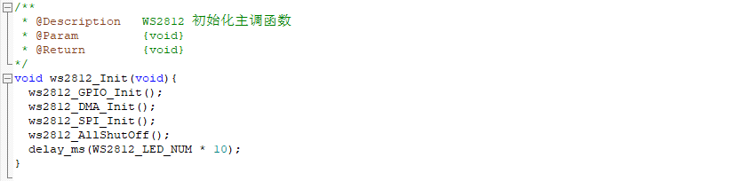

* 1. Turn on all lights

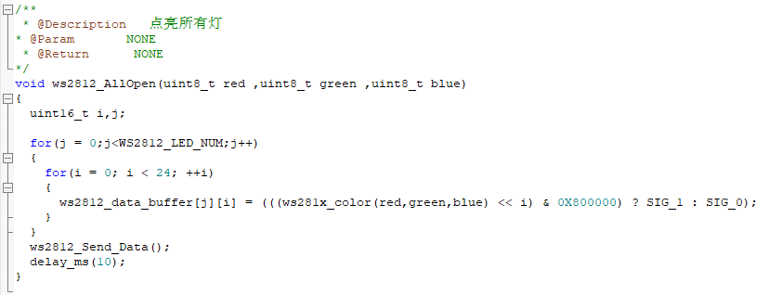

* 1. RGB color switching

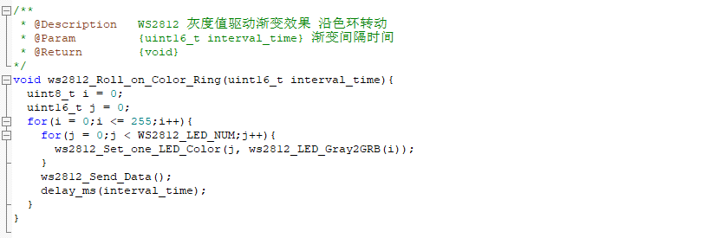

* 1. Colorful running lamps

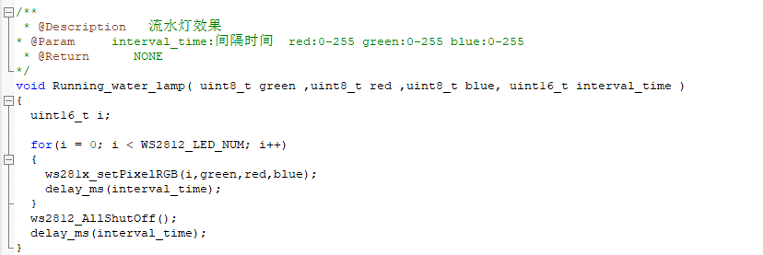

* 1. Marquee

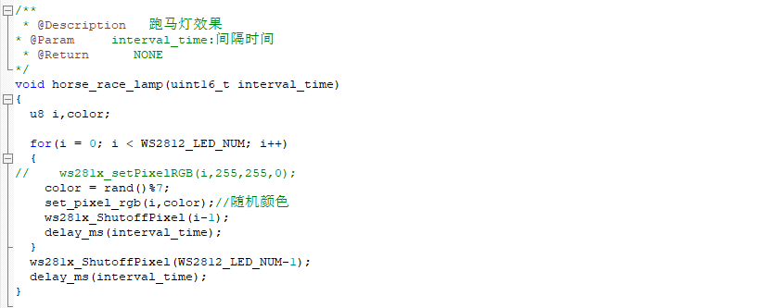

* 1. Breathing lights

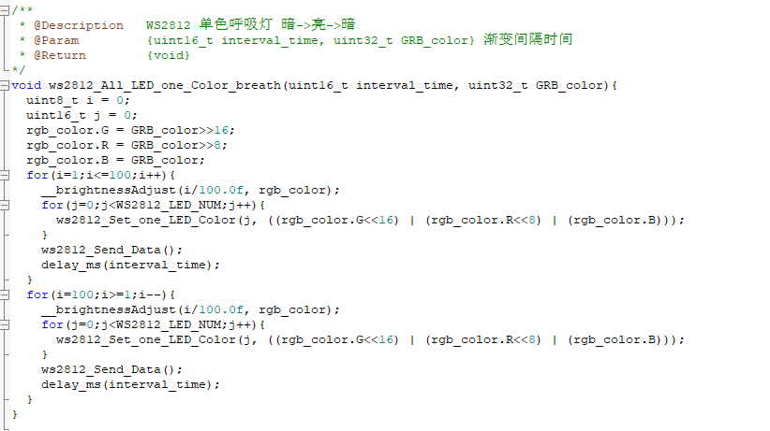

* 1. Randomly light the RGB lamp

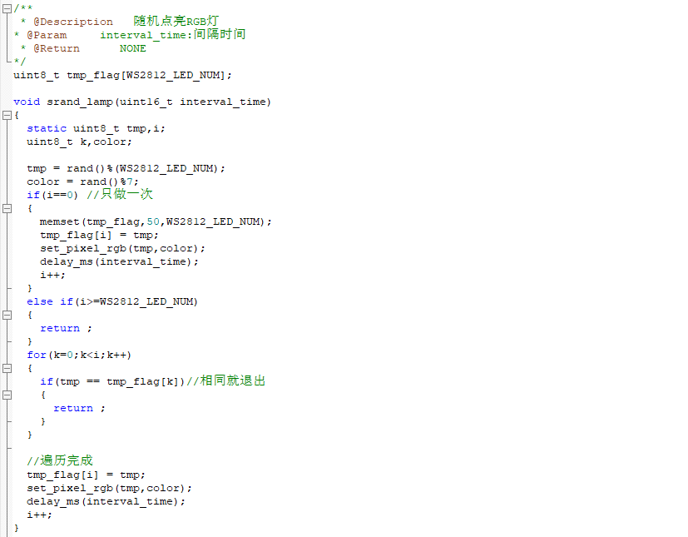

### 2. Experimental phenomenon

1. Turn on all lights

After the program is downloaded, all the RGB lights on the strip are lit blue

**5**



**14**

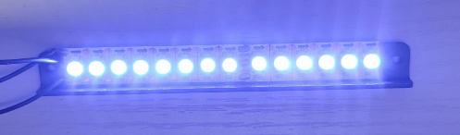

1. RGB color switching

After downloading the program, all the RGB lights above the strip change in 7 different colors

**5**

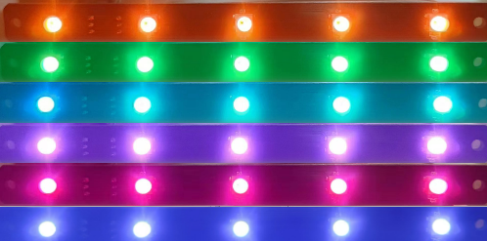

**14**

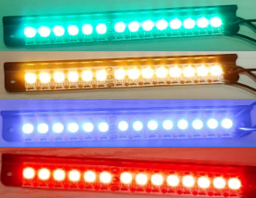

1. Colorful running lamps

After the program is downloaded, all the RGB lights on the strip are lit green in turn, then turned off, and then lit up in turn, and so on

**5**

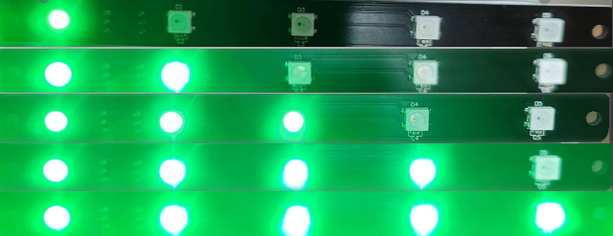

**14**

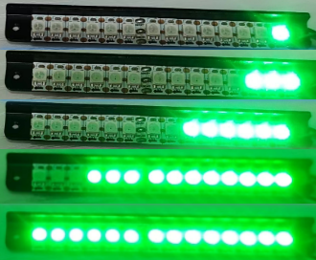

1. Marquee

After the program downloads, all the RGB lights on the strip are lit in different colors in turn

**5**

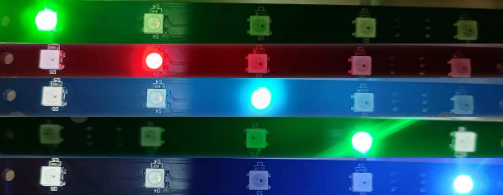

**14**

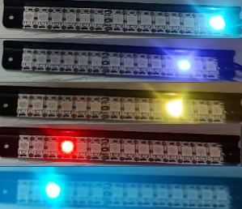

1. Breathing lights

After the program is downloaded, all the RGB lights on the light bar cycle from on to off, and then from off to on

**5**

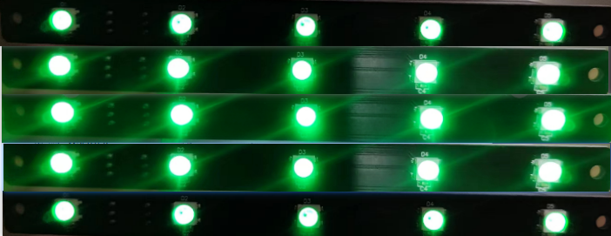

**14**

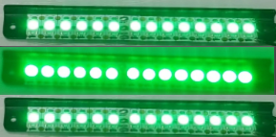

1. Randomly light the RGB lamp

After the program downloads, all RGB lights on the light bar are randomly lit one by one until all RGB lights are fully on

**5**

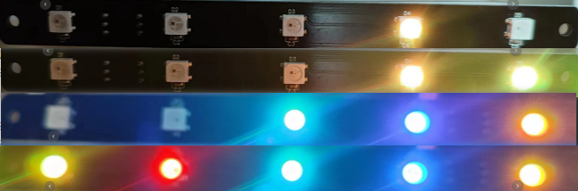

**14**

